SECTION 7 DRIVEWAYS
The authority for standards for driveway design in the Transportation Criteria Manual is given by the Land Development Code (LDC). This section provides minimum and desirable design criteria, provisions, and requirements for safe and convenient access to abutting properties along streets and highways. The purpose of this section is to assist City staff and private sector street design professionals in applying a consistent approach to driveway design.

7.1.0 DESIGNING FOR SAFETY
Driveway placement shall ensure access is provided to properties while minimizing the number of driveways needed to maintain efficient vehicular access, which in turn reduces the number of conflicts for pedestrians and bicycles along a street. Managing access ensures minimum interference with the free and safe movement of pedestrians, bicycles, vehicles, and other modes of travel. Safety shall be held paramount to all other interests per the ASMP. To this end, the intent of this section is to provide access, while designing driveways with the lowest width and corner radii feasible for the necessary design vehicle, leading to slower turns, safer maneuvering, and safer pedestrian and bicycle facilities.

7.2.0 DESIGN CONTROLS
The driveway is defined as the area between the edge of the vehicular travel lanes and the property line. See Figure 7-1 for area marking this defined area for a driveway. The subsections that follow in this Section outline the driveway design criteria to be used on driveway access connections in the City of Austin. For driveways on TxDOT facilities, TxDOT shall be consulted as part of the driveway permitting and approval process.

7.2.1 DESIGN & CONTROL VEHICLES
To balance the needs of vehicular and non-vehicular users at each driveway, careful attention needs to be placed on which type of vehicles require access to each site. Vehicle types are broken into two categories similar to Section 3.2.1, design vehicles and control vehicles. The design vehicle is a frequent user accessing the site and serves as the primary vehicle for which driveway geometries are determined. The control vehicle is an infrequent user accessing the site that must be accommodated while maintaining safety for pedestrian and bicycle users. Control vehicle turning movements can be made possible by the installation of mountable curbs and surfaces at the curb radii only if compliant with provisions in Section 3.6.2.2.
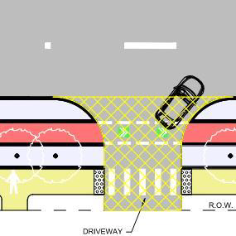
Figure 7-1 — Driveway Area

7.3.0 DRIVEWAY ACCESS TYPES
Regardless of driveway access type, all driveways shall be designed to maximize safety and reduce conflicts between all road users. Driveways along a street provide access to varying land uses which require different design criteria for each access type. Driveway access types are separated into two primary categories, minor and major driveways. Each access type category as well as sub-categories are explained in further detail below. For driveways on streets with multiple through travel lanes in either direction and a posted regulatory speed of greater than 35 mph, left turns exiting the driveway shall not be allowed from intersecting driveways without a traffic signal or other operation to protect left turns from the intersecting driveway without City Traffic Engineer, applicable Director, or their designee's approval.

7.3.1 MINOR DRIVEWAY
A. Defined as driveways providing access to the following developments:
1. Single Family Residences.
2. Duplex.
3. Multi-Family units made up of 4 or fewer units.
B. Minor driveways shall be built to Type I driveway construction standards in the Standards Manual.
C. Minor driveways shall be prohibited from taking access to Level 3 and Level 4 Streets.

7.3.2 MAJOR DRIVEWAY
Defined as driveways providing access to the following developments:
A. Commercial. Office, retail, service station or institutional building. It should be expected that these developments will require access by emergency as well as routine delivery and refuse vehicles.
B. Mixed Use Developments (Residential & Non-Residential).
C. Multi-Family units made up of greater than four units
D. Industrial. Will require truck movements accessing an industrial, manufacturing, warehouse, or truck terminal facility to load and unload goods.
E. Other non-residential uses. Major driveways shall be built to Type II driveway construction standards in the Standards Manual.

7.3.3 SPECIAL ACCESS TYPES
A. Access to Level 0 Streets requires approval by the City Transportation Engineer or applicable Director. Access to and from unimproved Level 0 Streets is not allowed. If an applicant wishes to have access to an unimproved Level 0 Street, they must obtain approval by the City Transportation Engineer or applicable Director and improve the Level 0 Street to current City Standards. The decision to access a Level 0 Street is optional and any improvement will not be credited toward Rough Proportionality as defined in Section 10.
B. Areas used as motor vehicle service stations or parking lots shall have a 6 in. raised curb along the entire street frontage except at the driveway approaches and curb ramps.
C. For driveways that are designated as fire access only, roll curbs shall be used as standard and driveways shall be at sidewalk elevation. Fire access only areas may be used as part of a trail connection or as a link in an existing or future trail system if approved by both Austin Fire Department and Development Services Department.

7.4.0 DRIVEWAY DESIGN TYPES
Land use types vary and change along a street over time, which results in different access needs and requirements for how each access point shall be designed. The benefits of each driveway type should be considered when planning new access points or retrofitting existing access points along a street, with the safety of non-vehicle users as a primary consideration. The three primary driveway types are shown in Figure 7-2 and are listed in this section with their intended use explained in greater detail.
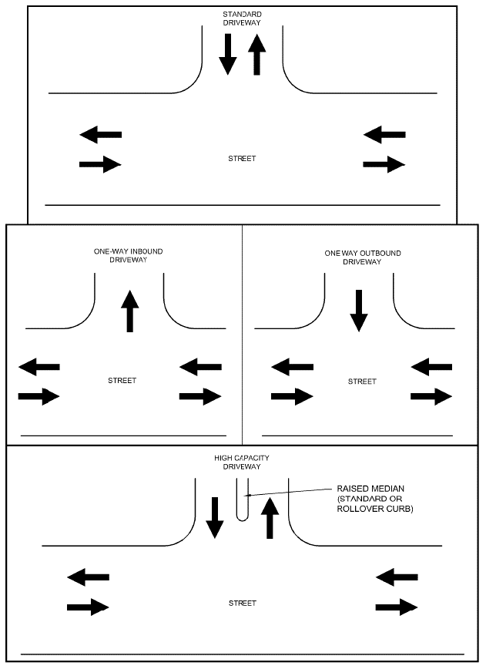
Figure 7-2 — Driveway Types

7.4.1 STANDARD DRIVEWAY
A standard driveway provides two-way access at a single, undivided curb opening. Dimensions will vary based on access type and Street Level of abutting street per Section 7.5.0. This includes minor driveways, which will be narrower with smaller turning curb radii.

7.4.2 ONE-WAY DRIVEWAY
One-way driveways provide only inbound or outbound access. On-site circulation must be provided to ensure that vehicles can safely and efficiently access both the inbound and outbound access points.

7.4.3 HIGH CAPACITY DRIVEWAY
High capacity driveways provide two-way access separated by a raised median at a single curb opening, except when the driveway directly accesses a parking garage. Geometric modifications such as increased width of the driveway opening, increased curb radius, and a raised median to separate traffic shall only be considered if they do not negatively affect pedestrian or bicyclists' safety.
A. High capacity driveways may only be used in locations where peak hour volumes are expected to exceed 50 vehicles in any peak hour based on the latest edition of the ITE Trip Generation Manual.
B. Special consideration shall be given to designing for both design and control vehicles in Section 7.2.1 by utilizing means such as mountable surfaces while preserving safety for pedestrians and bicyclists.
1. Increasing the curb radius beyond Section 7.5.1.1 maximums will only be considered if the applicant can demonstrate the maximum allowable curb radii cannot accommodate design and/or control vehicles and that the larger radii do not negatively impact safety.
C. The raised median on a high capacity driveway shall include pedestrian waiting areas or cut throughs per Section 4.2.4.2, which shall be properly designed to meet ADA requirements and Section 4 of the TCM.
D. When high capacity driveways serve a garage across a zero lot line pedestrian zone, accommodations shall be made to increase visibility and awareness of street users crossing the driveway to drivers exiting the garage.

7.5.0 DRIVEWAY GEOMETRIC DESIGN CRITERIA
The geometry of a driveway will: 1) determine how a vehicle transitions from the through lanes of the abutting street and traverses the driveway to the subject site, and 2) should serve to maximize safety for all users. The geometric design criteria set forth in this section shall be followed on new and existing driveways. Figure 7-3 illustrates the features of a driveway.
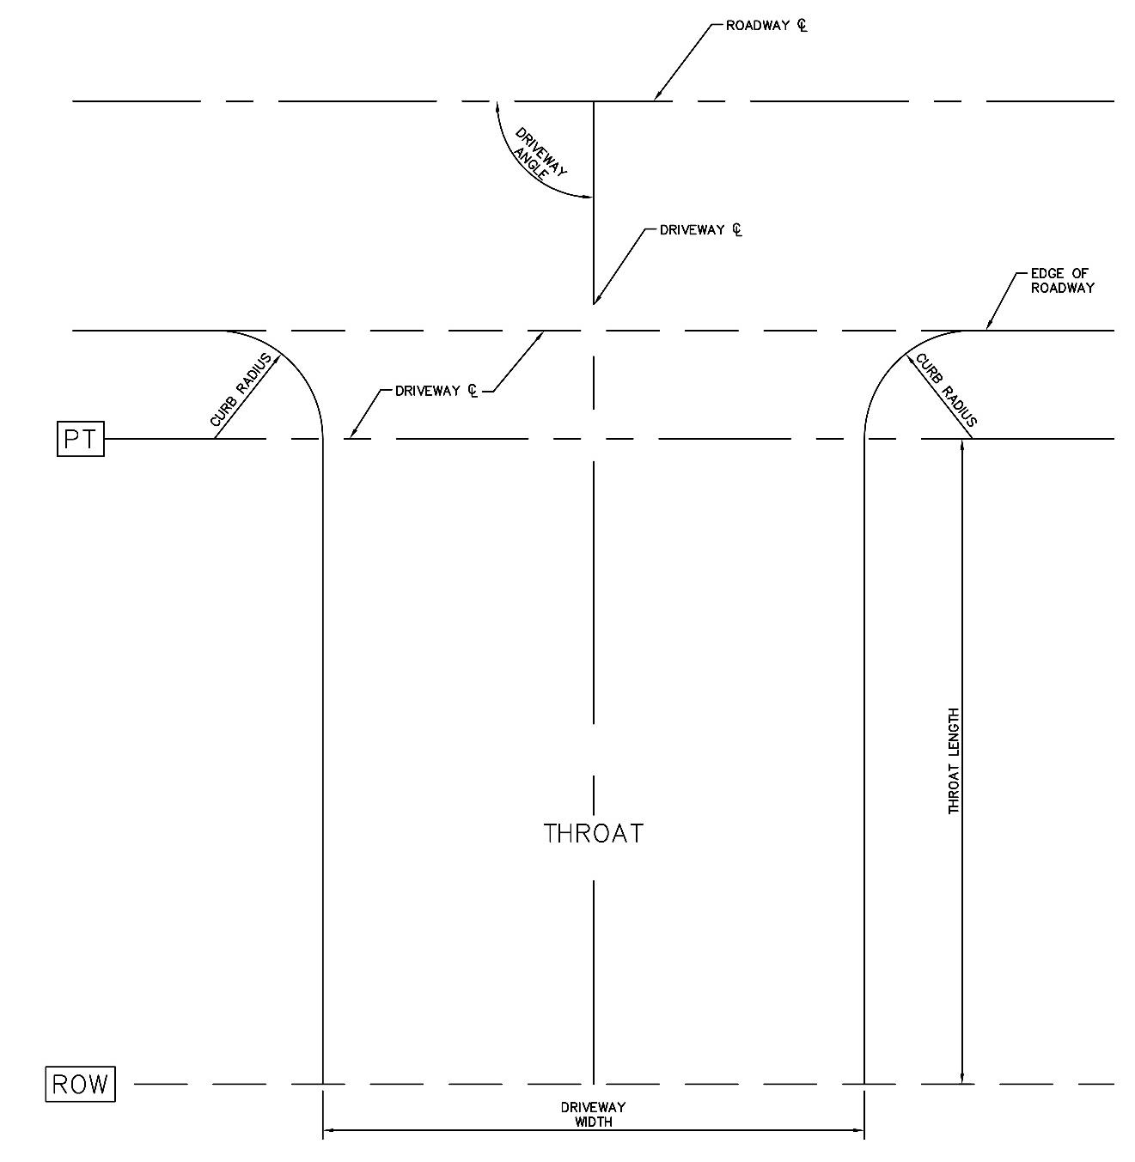
Figure 7-3 — Driveway Geometric Features
A. If deviating from the criteria in this Section, vehicle swept path analysis shall be run with computer aided design software to ensure the proposed driveway geometric configuration allows the design vehicle to maneuver the driveway geometry without off tracking.
1. The design engineer shall also provide a swept path analysis for control vehicles and shall make provisions to accommodate control vehicles while maintaining safety for pedestrians and all other users.
B. Refer to City of Austin Standard Details for construction standards for driveways.

7.5.1 DRIVEWAY APPROACH

7.5.1.1 Driveway Curb Radius.
The curb radius of a driveway refers to the curb return or transitional area between the through lanes of the street and the throat of the driveway. The primary purpose of the curb radius on a driveway is to balance access and safety for entrance and departure from a site. A larger curb radius allows vehicles with a larger turning radius to enter or exit a site without encroaching beyond the curb radius. There is a direct correlation between the radius and the speed at which vehicles can complete a turn. Therefore, minimizing curb radius for design vehicles, defined in Section 7.2.1, is the priority when designing driveways to reduce speed.
Table 7-1 below lists the curb radii that shall be used on driveway designs depending on Street Level and land use. In scenarios where a design vehicle cannot navigate a turn into a driveway without encroaching across the curb radii listed in Table 7-1, the design engineer shall demonstrate this and make provisions for control vehicles such as delivery, refuse, or emergency vehicles while maintaining safety for pedestrians and other users.
Table 7-1 — Driveway Curb Radius Criteria
Street Level³ | Typical¹ | Fire Access² | Industrial⁴
Level 1 | 10 | 15 | 15
Level 2 | 10 | 15 | 15
Level 2 - 3 lane (center turn lane) | 15 | 15 | 25
Level 3 Single Lane Median | 15 | 20 (In)  25 (Out) | 25 (In)  50 (Out)  ⁶
Level 3—4 Multi-lane | 15 | 15 | 20

1. Major driveways without fire access or industrial/commercial access with heavy large trucks. Minor driveways shall be designed per Type I driveway standards in the Standards Manual.
2. Serves as a fire access lane.
3. Street Level refers to the street type that vehicles use to access a site.
4. As defined in Section 7.3.2(D).
5. Driveway design shall allow design vehicles to safely traverse a turn without encroaching on pedestrian or bicycle space outside the traveled way. Bulb-outs, setback stop bars and other strategies may be used as defined in Section 3.
6. Driveway turn radius within the Downtown area in Figure A-2 shall follow Great Streets Master Plan standards. Driveway turn radius within the University Neighborhood District Overlay (UNO) shall follow UNO standards.
7. When large design vehicles are expected, the use of a compound curve rather than a simple radius design or a mountable median may be used to reduce pavement required.
8. Areas where the apparatus body envelope of the control vehicle is anticipated to pass behind the face of curb or edge of pavement shall be clear of any vertical obstructions under 8 ft. height.

7.5.1.2 Driveway Widths.
The driveway width defines the width of the driveway throat as shown in Figure 7-4, measured from face of curb to face of curb or edge of pavement to edge of pavement. Driveway width will vary depending on the land use being accessed as well as the vehicles that are forecasted to use the driveway. Access requirements of the site must be identified when determining the number of lanes required. Table 7-2 specifies the driveway widths. Driveway widths shall be minimized as much as possible to shorten crossing distances and decrease exposure for vulnerable users crossing the driveway.
Table 7-2 — Maximum Driveway Width (Throat Width)^{5, 6}
Street Level³ | Typical¹ | Fire Access² | Industrial⁴
Level 1 | 20 | 20 | 25
Level 2 | 20 | 20 | 25
Level 2 - 3 lane (center turn lane) | 20 | 25 | 25
Level 3 Single Lane Median | 20 | 25 | 25
Level 3—4 Multi-lane | 20 | 25 | 25

1. Major driveways without fire access or industrial/commercial access with heavy large trucks. Minor driveways shall be designed per Type I driveway standards in the Standards Manual. As defined in Section 7.3.2 (A) through (C).
2. Serves as a fire access lane.
3. Street Level refers to the street type that vehicles use to access a site.
4. As defined in Section 7.3.2(D).
5. Driveway widths listed above for two-way driveways only include one lane in each direction.
6. High capacity driveways serving a parking garage may have a driveway width of 32 ft. maximum to accommodate 3 lanes of travel for ingress and egress operations.

7.5.1.3 Driveway Angle.
The angle of the driveway refers to the angle the centerline of the driveway makes with the centerline of the street. Driveways shall be 90 degrees to the through lanes. Angles less than 90 degrees are not allowed as they encourage faster turning speeds which are not desired for safety on pedestrian facilities. Angles that deviate from 90 degrees also negatively affect the sight line of departing vehicles.

7.5.2 DRIVEWAY GRADES
A driveway grade is defined as the vertical change per foot at the centerline of a driveway. Sidewalks and bikeways shall have raised crossings at driveways, maintaining their elevation for a safer crossing that increases visibility and encourages yielding by turning vehicles. Driveways shall maintain the minimum and maximum driveway grades, diverting storm water flow, and meet all ADA requirements. Figure 7-4 illustrates how driveway grades are to be applied to driveway design and Table 7-3 outlines driveway grade criteria.
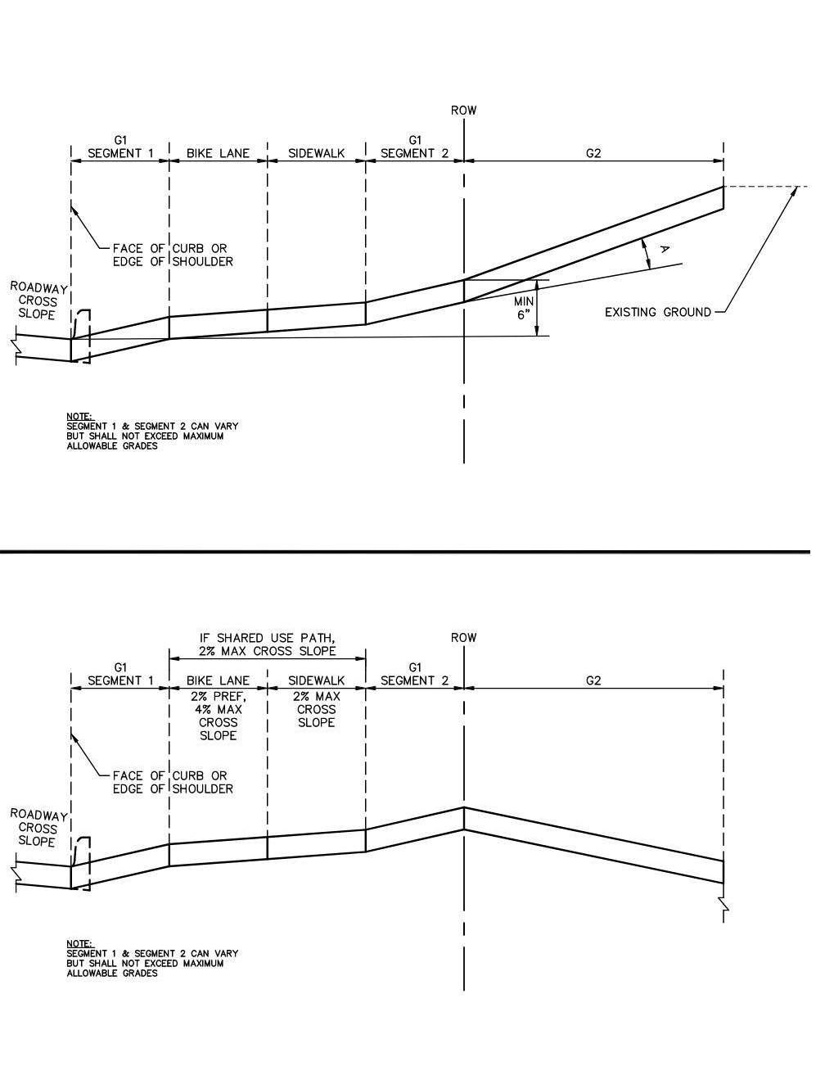
Figure 7-4 — Driveway Grades

7.5.2.1 Driveway Grades Design Criteria
Table 7-3 — Allowable Driveway Grades⁵
 |  | G₁(Segments 1 and 2) | G₂
Major | Commercial² | 2—10% | Max. 12%
Major | Industrial | 2—10% | Max. 12%
Minor¹ |  | 2—12% | Max. 15%

1. As defined in Section 7.3.1.
2. As defined in Sections 7.3.2(A) through 7.3.1(C).
3. G ₂ is determined by the design engineer based on site conditions and end user requirements.
4. Maximum allowable grade change of 13.3% between G1 Segment 1 and intersecting street and G1 Segment 2 at G2 to prevent bottoming out or high centering of vehicles.
5. Reference latest Standard Details for grades, which may supersede this manual, subject to final approval by the City Traffic Engineer or applicable Director.
A. Figure 7-5 reflects the acceptable driveway profile intended to limit abrupt changes in grades. The value of G1 is limited by street cross slope or behind curb elevation profile. G1 shall not exceed 6% for major driveways and 12% for minor driveways.
B. The driveway grade shall meet all state and federal ADA requirements for accessibility through the pedestrian crossing area.
C. All sidewalk and bicycle lane crossings of driveways shall maintain the elevation of the sidewalk and bicycle lane in a raised crossing.
D. Driveway elevations at the ROW line of a public street shall be a minimum of 6 in. above the street gutter. A minor driveway that intersects a Level 0 Street shall be a minimum of 3 in. above the edge of the Level 0 Street pavement at the ROW line.
E. Driveway grade change in a fire lane shall not exceed 6%.
F. Vertical clearance along utilities in the driveway shall meet utility clearance and access requirements per the Utilities Criteria Manual.

7.6.0 ACCESS MANAGEMENT
Access Management is a term used to describe how access to varying land use contexts are regulated and designed along a street. Criteria for how land can be accessed must differ depending on the context and the intended mobility of each street. Access management, future land use and roadway network planning are all connected, and if managed properly, will lead to safe and efficient street operations for all street users. Current and future access requirements must be considered for the property in consideration and adjacent properties during the planning and design phase, as it will allow the entire street network to operate most efficiently.
The primary goals of access management criteria are to minimize conflicts between all street users, improve safety, and maximize the efficiency of each driveway along the street. There is a direct correlation in the number of driveways along a street and the amount of traffic delay and conflict points. Best practice is to consolidate driveways with the use of joint use driveways during the redevelopment of existing property and the new development of vacant land. Joint use driveways are discussed in further detail in Section 7.6.4.
Proposed driveway access shall be identified in an applicant's Transportation Impact Analysis per Section 10.

7.6.1 PROPERTY FRONTAGE DRIVEWAY REQUIREMENTS
Each property's frontage length will vary along a street and access requirements will vary as well. Table 7-4 outlines the allowed number of driveways based on property frontage available.
Table 7-4 — Maximum Site Access Connections
Property Street Frontage (ft.) | Maximum Number of  Allowable Driveways
<300 | 1
300—600 | 2
>600 | 3

Driveways on adjacent sites must be considered and driveway must be placed in accordance with spacing requirements outlined in Section 7.6.2. Sight distance requirements per Section 3.4.2.1.1 shall be considered for placement of new driveways or when changing use of existing driveways.

7.6.1.1 Multi-Unit Residential Development accessing Minor Drives on Level 1 Streets
While the driveway spacing requirements of 7.6.1 and 7.6.4 encourage driveways to be consolidated as much as possible, residential infill sites are unique and those sites with pre-existing obstacles may require relief from the spacing and consolidation standards of these Sections as described below:
A. If a lot fronting a Level 1 street has less than 300 feet of street frontage and at least two dwelling units are proposed on the lot, two driveways are allowed if at least 20 feet of spacing can be provided between driveways.
The 20-foot driveway spacing requirement may be reduced administratively if any of the following site conditions prevent the required spacing:
1. Existing and proposed utility infrastructure such as a power pole, drainage inlet, water meter, wastewater cleanout, manhole, or fire hydrant on site or in the ROW frontage;
2. A drainage easement on-site;
3. Protected or Heritage trees located on-site or on an adjacent site such that the required driveway spacing would result in impacts exceeding Standard Preservation Criteria as identified in Environmental Criteria Manual Section 3;
4. There is a slope of greater than 8% outside of the apron in the right-of-way.
If less than 20 feet of street frontage is proposed between the two driveways, the applicant shall identify the applicable site condition above and provide sufficient documentation why the site condition creates a constraint on driveway spacing with any permit application.
In addition to the above option, a corner lot may have one driveway on each street that it fronts provided that each driveway meets all other TCM spacing and offset criteria and does not create a circular driveway (the driveways must be independent and not create a circular drive).
B. For a corner lot fronting a Level 1 street where three dwelling units are proposed, three driveways are allowed if the site meets the following criteria:
1. Two driveways are provided along the long side and one driveway along the narrow side of the lot;
2. Minimum 20' spacing between proposed driveways on the long side of the site;
3. Driveways on the long side of the site must meet TCM spacing criteria from storm drain inlets (10' between the inlet opening edge and the driveway point of tangency with the street) and street intersections (50'). The driveway accessing the short side of the site must meet TCM spacing criteria from storm drain inlets and be at least 30' from the intersection.
4. A corner lot must not create a circular driveway that connects access from both streets.
If three driveways are proposed, the applicant shall identify the site conditions above on the associated application.
Sites complying with the three-driveway criteria do not have to demonstrate compliance with TCM 7.6.1.1.A (two-driveway criteria) to provide two drives along the long side of the site.
The requirements for three driveways may be modified administratively if any of the following site conditions prevent use of a shared driveway in lieu of a third driveway:
1. Existing and proposed utility infrastructure such as a power pole, drainage inlet, water meter, wastewater cleanout, manhole, or fire hydrant on site or in the ROW frontage;
2. A drainage easement on-site;
3. Protected or Heritage trees located on-site or on an adjacent site such that the requirements would result in impacts exceeding Standard Preservation Criteria as identified in Environmental Criteria Manual Section 3;
4. There is a slope of greater than 8% outside of the apron in the right-of-way;
5. Other site-specific conditions.
The applicant shall identify the applicable site condition above and provide sufficient documentation why the site condition prevents the use of a shared driveway in lieu of a third driveway.
C. Driveway spacing for this section is measured where the drive crosses the property line. Please refer to Figure 7-8.
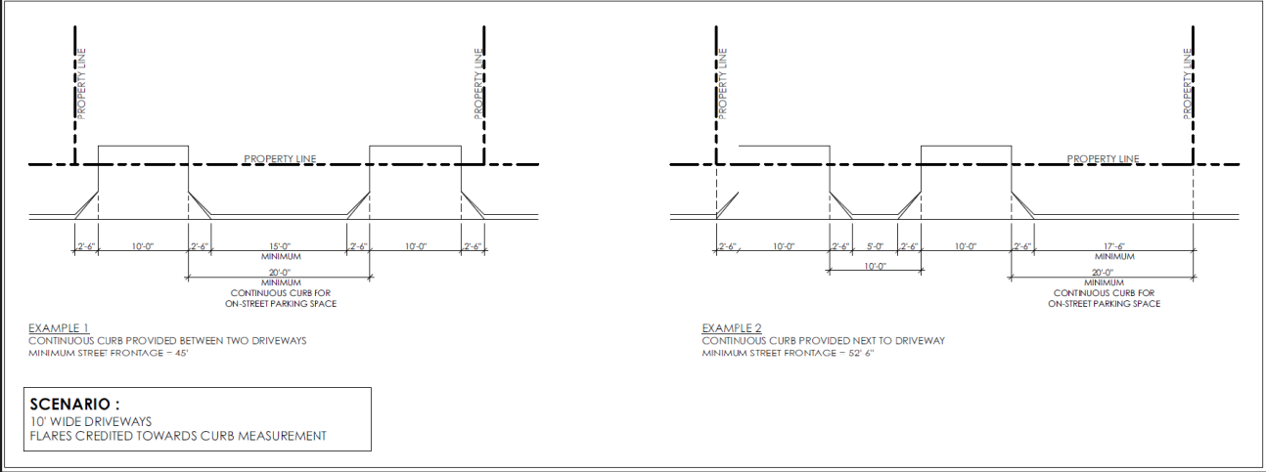
Source: Rule No. R161-24.01, 5-30-2024; Rule No. R161-25.15, 10-29-2025.

7.6.2 DRIVEWAY PLACEMENT
Driveways operate together along a street and their placement affects the safety and efficiency of a street to move vehicles through and to adjacent properties. Several factors must be considered when determining the placement of the driveway:
1. Street Level that the driveway draws access from;
2. Target speed of the street;
3. Level of non-motorized vehicle activity;
4. Amount of site frontage available to be accessed;
5. Approach directions of traffic in need of accessing the development;
6. Location of existing cross streets and traffic signals;
7. Traffic signal coordination requirements;
8. Proximity to other proposed and existing driveways; and
9. Intersection sight distance per Section 3.4.2.1.1.
Table 7-5 defines minimum spacing based the Level of the street access is being taken from and driveway access type. Spacing driveways per criteria in Table 7-5 with respect to other driveways and intersections will maximize the traffic safety, flow, and operations of the street. The dimensions in Tables 7-5 for spacing between driveways should be increased whenever possible so that the number of driveways can be reduced. Dimension control for applying the criteria in Table 7-5 is shown in Figure 7-5.
Table 7-5 - Minimum Driveway Spacing¹
Street Level² | Minor Driveway | Major Driveway
4 | N/A | 280
3 | N/A | 200
2 | 75 | 150
1 | 50 | 75

1. Distances are measured from inside edge of pavement of each driveway or the edge of the intersecting street travel lanes as in Figure 7-5.
2. Street level refers to the street that vehicles are using to access the site. Level 5 streets do not have driveways.
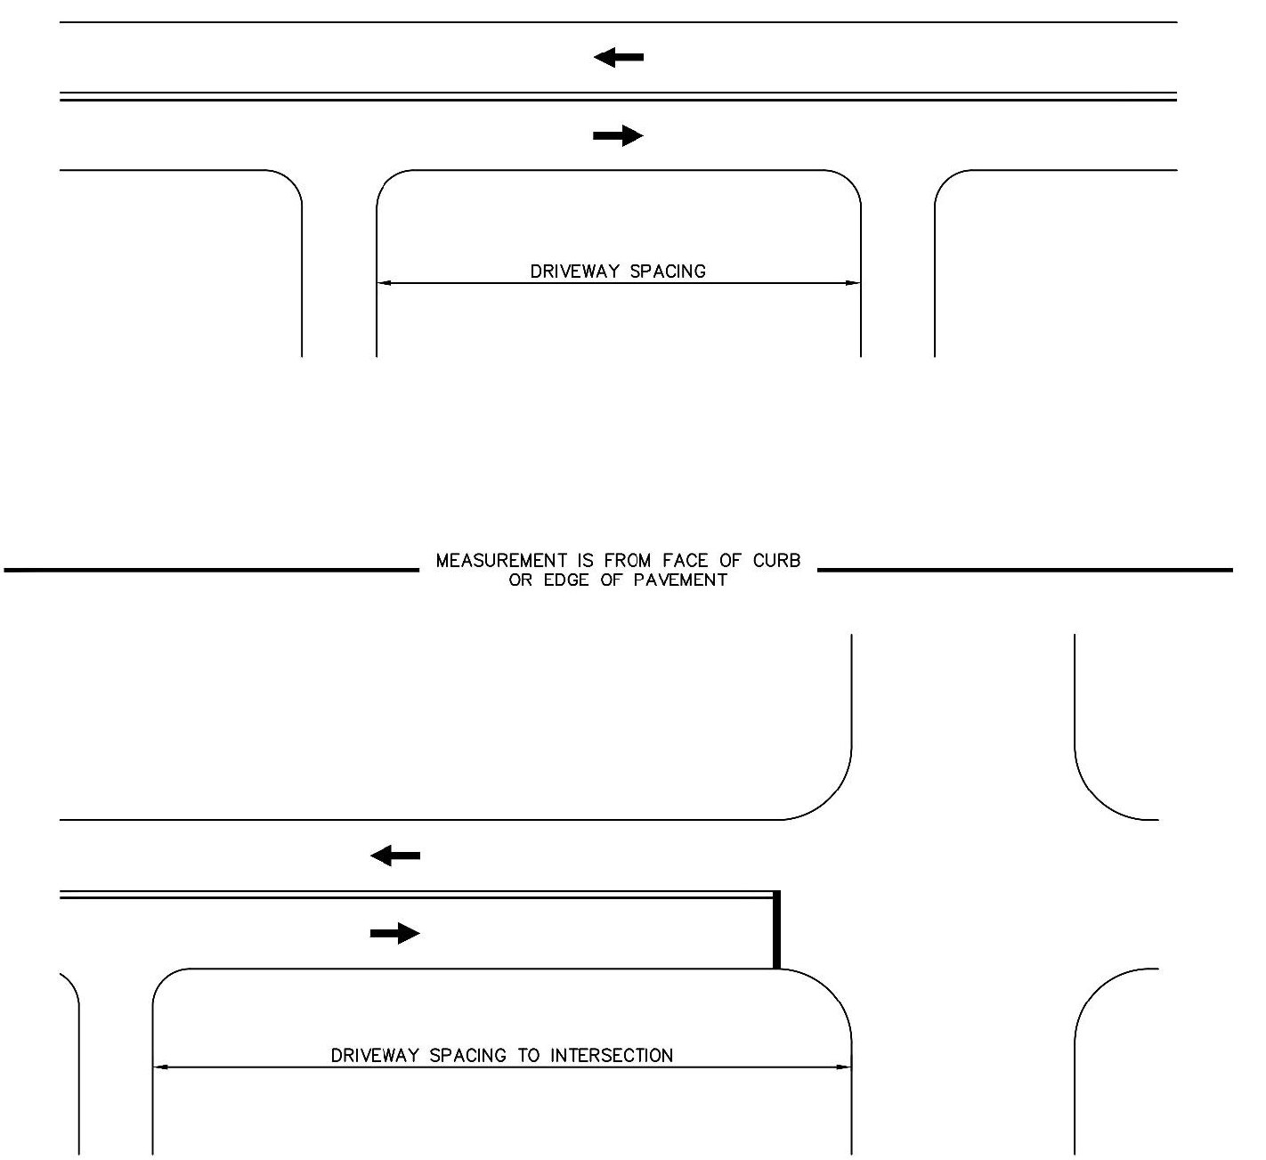
Figure 7-5 — Driveway Spacing
A. When a property is at the corner of two streets, access shall be provided along the intersecting street with the lower Street Level unless property frontage exceeds 200 ft. on the higher Level street (or shortest frontage exceeds 200 ft. when both streets are the same Level) or multiple points of access are required for the site due to Fire Code or the LDC.
B. When a property is in a mid-block location and only accessing one street, preferred placement is the midpoint of the property or midpoint between driveways on adjacent properties to maximize driveway spacing along the street.
C. If a curb inlet is present, there shall be 10 ft. between the inlet opening edge and the driveway point of tangency with the street.
D. All driveways must be constructed within the street frontage of the subject property, as determined by projecting the side property lines to the curb line. Neither the driveway nor the curb returns shall encroach upon this projected line or onto adjacent property frontage without written approval from the adjacent property owner.
E. Alignment of driveways with opposing streets at signalized intersections shall be approved by the City Transportation Engineer or applicable Director. If such a design is approved, the driveway approach may be constructed without an apron and the maximum driveway widths as shown in Table 7-2 may be increased to match the cross-section of the opposing street. Construction of these driveways shall be built as new street intersection leg and signal modification costs shall be borne by the applicant and not be credited towards Rough Proportionality as defined in Section 10.
F. Driveways shall not be permitted in the taper area of any right-turn lane or any part of a right-turn lane.
G. Driveways that intersect at a mid-block median opening shall have the driveway centerline intersect with the midpoint of the median opening (measured nose-to-nose).
H. Full access driveways shall not be permitted where it is necessary for left turning vehicles coming out of the development to cross an existing left turn lane.
I. Additional driveway placement design criteria are contained in Section 7.6.1.

7.6.3 OPPOSING DRIVEWAYS WITH OFFSETS
Driveways on opposing sides of an undivided street with offsets can result in conflicting movements in and out of driveways and within the street.
A. If left turning paths into driveways on opposing sides of a street cross each other (offset left), access shall be restricted to right-in, right-out, with the exception of a hooded left-turn into one driveway.
B. If left turning paths into driveways on opposing streets do not cross each other (offset right), the driveways shall be located to avoid conflicting left turns out of the opposing driveways and placed a minimum of 80 ft. apart measured from the throat edge of an intersecting driveway and the throat edge of the opposite intersecting driveway.

7.6.4 JOINT USE DRIVEWAYS
Joint use driveways provide direct access to adjacent properties through a single driveway. This method of driveway placement is recognized as driveway consolidation and should be used as much as possible. Driveway consolidation reduces the potential of traffic delays and traffic conflicts; it minimizes curb cuts, resulting in a safer and more comfortable sidewalk environment for pedestrians and bicyclists. General principles for joint use driveway placement are illustrated in Figure 7-6.
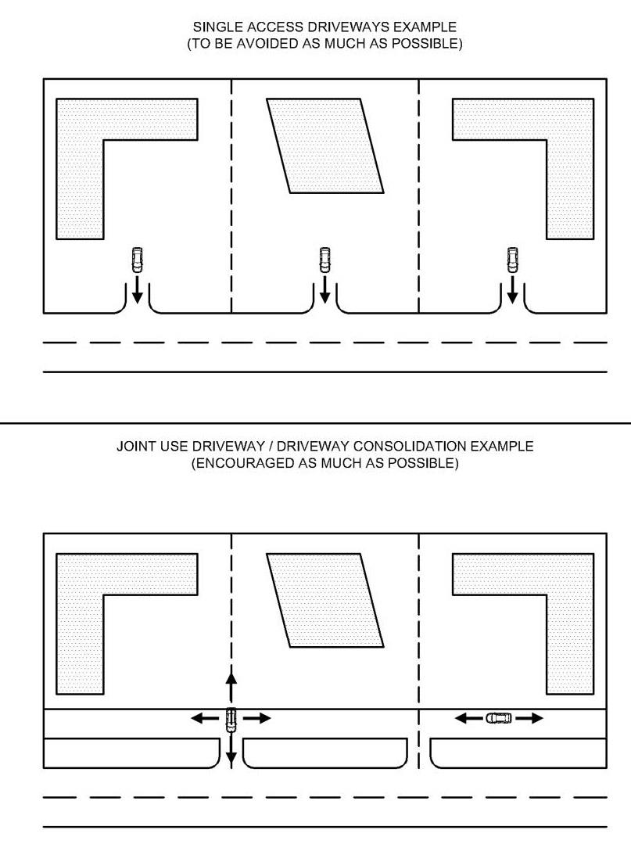
Figure 7-6 — Single Driveways and Driveway
Consolidation Examples
A. Design of joint-use driveways is subject to the same design criteria as minor and major driveways.
B. New joint use driveways are encouraged and will require an easement in a form approved by the City Attorney. The easement language will require that maintenance of the joint use driveway shall be the responsibility of the lot owners served by the joint use driveway.
C. Flag lots shall have a joint use access easement for a driveway accessing the lot if a joint use driveway is proposed.
Source: Rule No. R161-24.18, 2-12-2025.

7.6.5 TEMPORARY DRIVEWAY
A temporary driveway approach (Type III driveway) is intended to provide vehicular access to a lot or parcel of land, such access being from a roadway not yet constructed to permanent lines and grades or a roadway not having curb and gutter.
A. Temporary Type III driveways shall be reconstructed under the respective minor and major driveway standards within 60 days after construction of the abutting street to permanent line and grade with concrete curb and gutter.
B. Parking shall be prohibited in a temporary driveway if Austin Fire Department will need to use the driveway in the event of an emergency.
C. Placement and spacing of temporary driveways are subject to same standards as permanent driveways.
D. A Temporary Type III driveway variance grant shall be required per the Variance Grant form shown in Figure 7-7.
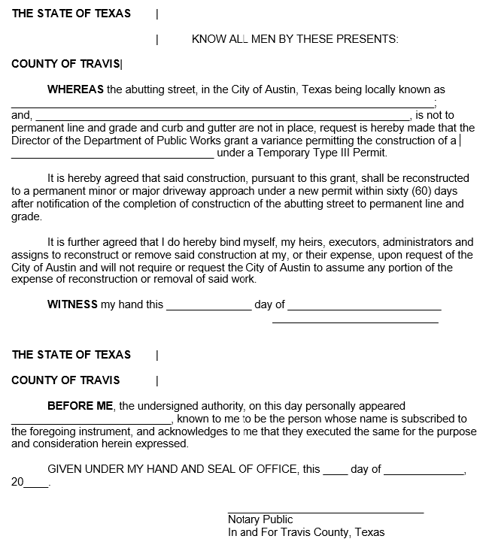
Figure 7-7 — Variance Grant for Temporary Type III Driveway

7.6.6 TEMPORARY CONSTRUCTION ENTRANCES
A. Temporary construction entrances shall be prohibited on commercial lots and residential lots with more than 4 residential units on Level 1 Streets.
B. Approval from the City Traffic Engineer, applicable Director, or their designee is required for temporary construction entrance change in location after the site plan has been approved.

7.6.7 LIMITED MOVEMENT DRIVEWAY ISLANDS
A. If channelized islands for limited movement driveways are approved, the applicant shall establish a maintenance agreement with the City.
B. Where a sidewalk, walkway, or an accessible path of travel, crosses a limited movement driveway island, it shall meet all state and federal ADA requirements for accessibility and comply with applicable requirements of Section 4 of this manual.

7.7.0 DRIVEWAY PERMITTING
The above standards and criteria specify the placement and design of driveways to build a driveway that accesses a site. A right-of-way construction permit must be granted for the driveway approach to be built. Refer to the LDC for permitting requirements.

